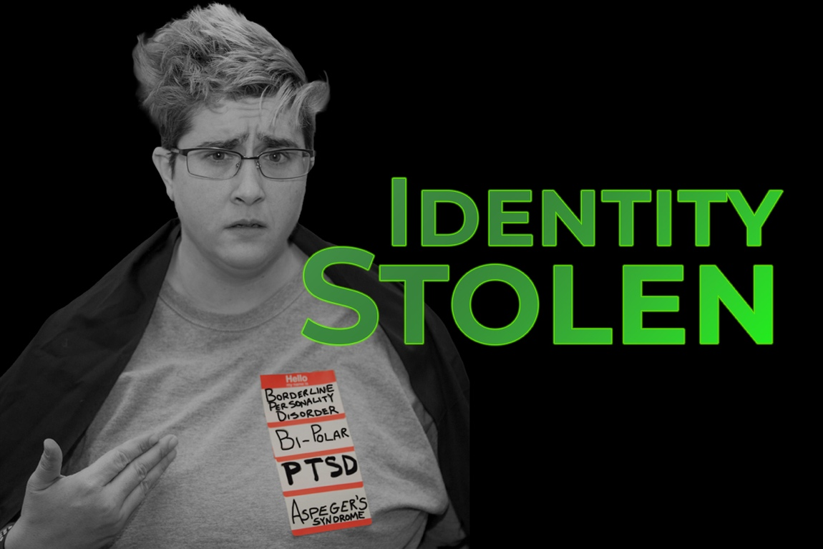

Training: Identity Lost

Welcome!
In this training session your staff will be made aware of just how the verbiage they choose to use when speaking to clients affects those around them.
For the GA DBHDD Certified Peer Specialist this training provides experiential learning to assist in serving as a recovery agent by supporting consumers in developing empowerment skill through self-advocacy and the use of Human Experience Language to combat stigma.
The following Peer Specialist Certification Training Competencies are covered in this training:
1G - Be able to support a consumer combat negative self-talk, overcome fears, and solve problems
2C - Understand the power of beliefs/values and how they support or work against recovery
2G- Be able to identify beliefs and values a consumer holds that works against his/her recovery

Recommended Audience

This training has been designed specifically for adults who interact with individuals with mental health conditions and other disabilities. Examples would include law enforcement, educators, mental health providers, counselors, faith leaders, first responders, clergy, hospital personnel and other community members.

What to Expect

This training was created to illustrate the power of words and to dispel the myth that a person’s life is limited because of the challenges they face due to mental illness, addictive disease or other disabilities whether they are the words we use to describe ourselves or others.

Learning Objectives:

This training will:

- Demonstrate the impact of the labels used in association with mental health and other disabilities.

- Discuss the importance of reducing stigma related to mental health and mental illness.

Requirements & Materials

TV with HDMI hookup and/or projector

Schedule a Training

Heather N. Croas, CPS, WHAM

Phone: 678-665-1012
E-mail: Recovery.Artist2019@gmail.com

